<Online Learning Platform>

Use-Case Specification: <Manage people>

Version <1.0>

Revision History

| **Date** | **Version** | **Description** | **Author** |
| --- | --- | --- | --- |
| <7/Dec/2021> | <1.0> | Initial version | Nguyen Tuan Nghia |
|  |  |  |  |
|  |  |  |  |
|  |  |  |  |

Table of Contents

1. Use-Case Name 3

1.1 Brief Description 3

2. Flow of Events 3

2.1 Basic Flow 3

2.2 Alternative Flows 3

2.2.1 < First Alternative Flow > 3

2.2.2 < Second Alternative Flow > 3

3. Special Requirements 3

3.1 < First Special Requirement > 3

4. Preconditions 3

4.1 < Precondition One > 3

5. Postconditions 3

5.1 < Postcondition One > 3

6. Extension Points 3

6.1 <Name of Extension Point> 3

Use-Case Specification: <Use-Case Name>

# Use-Case Name

## Brief Description

* *This use case allow teacher to manage people in the class*
* Subject: Teacher in the class
* This use case help user to manage people effectively

# Flow of Events

## First teacher clicks on (PEOPLE) button on the top of the main page this will lead teacher to the people tab. In this page teacher can see 2 section, one is (TEACHER) and one is (STUDENTS).

* In teacher section teachers can add or invite other teachers by clicking on (INVITE TEACHER) button. Then a pop up window will appear:

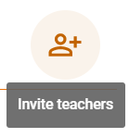

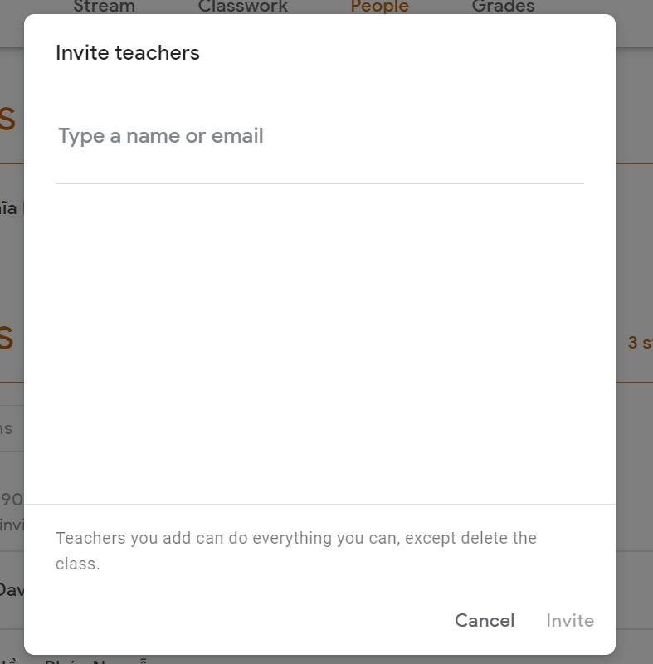

* Teacher types name or email of the person who they want to invite into a “Type a name or email” text box. After entering the email the text box turn into this  and teachers click the (INVITE) button which has now turned into orange in order to complete the action. Teachers can cancel their action by clicking  (CANCEL) button.

After invited successfully a pending message will be shown in the teacher section: 

* If the email’s domain of the person who has been invited is not valid a red notification bar will appear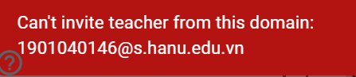. This bar will automatically disappear in 5 seconds and teachers have to delete the current email and retype a new one.
* In the student section teacher can add or invite student by clicking on (INVITE STUDENT) button. Same as the teacher section a pop up window will appear:

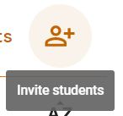

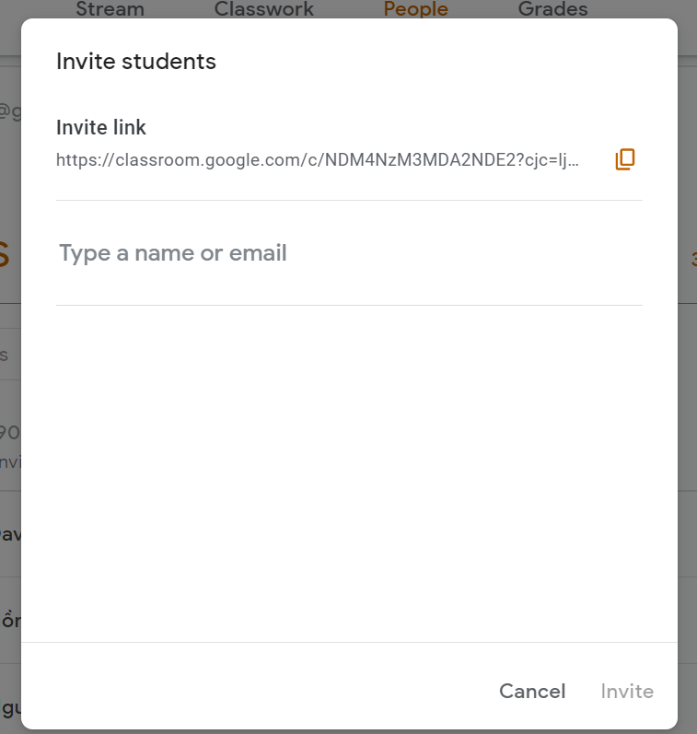

Teacher types name or email of the person who they want to invite into a “Type a name or email” text box and the rest of the flow are the same with Teacher section

* Teacher can sort student list by clicking on 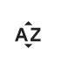 (SORTING BUTTON) then choose to sort the student list by (First name) or (Last name).

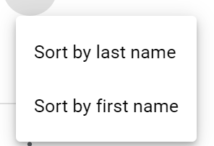

* Teacher can remove student by clicking on  button at the end of the student's bar. When the teacher hover mouse over the 3 dots button the blur grey circle will appear around the button.

 and click (REMOVE) option.

* Teacher can send email to student by clicking on button at the end of student’s bar 

and click (EMAIL STUDENT) option. It will move teacher to google mail interface and teacher can now send email to student.

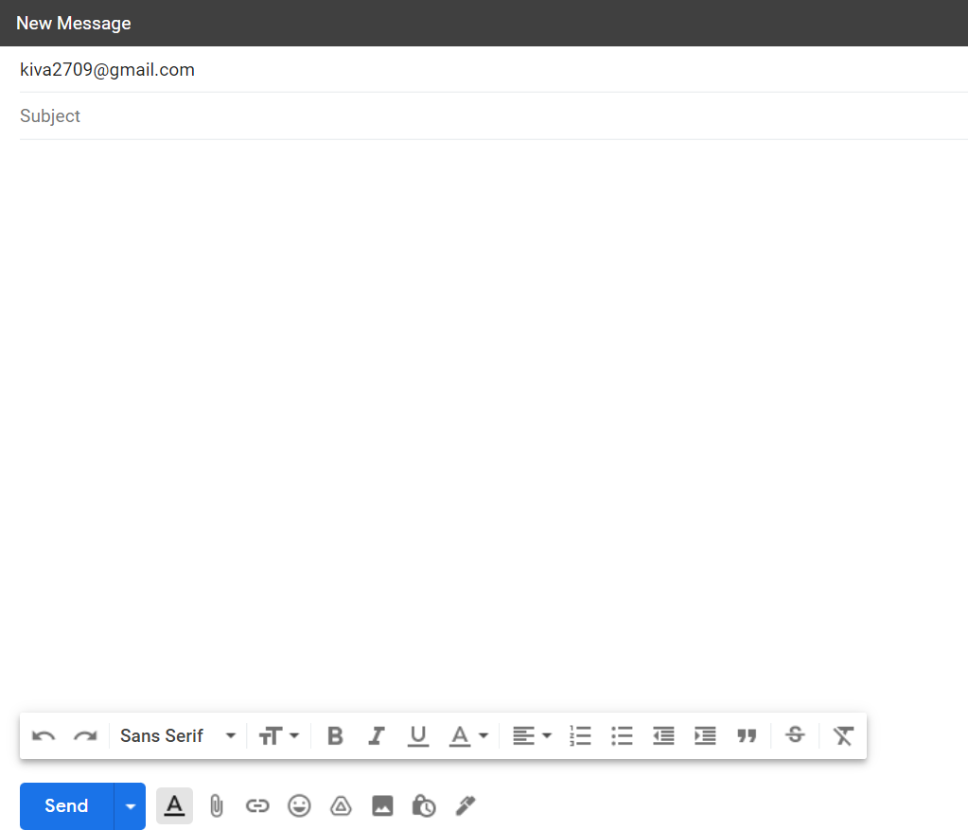

## Alternative Flows

# Special Requirements

## < First Special Requirement >

# Preconditions

# Postconditions

# Prototype

**